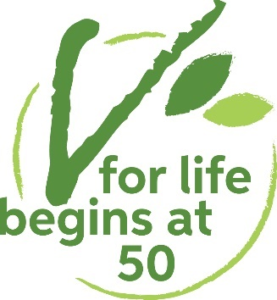
Pen and phone pals scheme

Please fill in the form overleaf if you would like an entry on our vegan and vegetarian pen and phone pals list. We update the scheme quarterly. So, after returning your form you will next hear from us when we release our next quarterly mailout.

As of October 2023, the scheme is only available to VfL supporters. You can become a supporter for as little as £3 a month. By doing so you’ll be helping to fund key services such as our grants to help independent living, highly subsidised publications, and our campaigns and advocacy work. For more information visit vforlife.org.uk/join.

Please read the notes below before filling in the pen and phone pals form:
- The details you supply will be used for compiling your entry and subscribing you to the pen and phone pal updates mailing list. However, they are not added to any other of our databases/mailing lists.

- This is NOT a dating agency. V for Life reserves the right not to include any inappropriate submissions of this form, including any without an authentic address.

- All accepted submissions will be circulated in the post to all later contacts. It is up to you whether you want to make the first contact or wait for someone to contact you. But if everyone waits not much will happen... try making the first move!

- Older entries are deleted automatically. You can usually expect to be on the list for about a year. Please contact us if you wish to remain listed for longer.

- Respect for other members is our only rule. This means only contact people if you match their search criteria e.g. only contact someone seeking female pen pals if you are female. Never attempt face to face contact without prior arrangement. If someone asks you to stop contacting them, do so immediately. If any of these regulations is overlooked, we will unfortunately have to ban you from the scheme.

- Beyond this… the scheme is for you to use as you feel! We hope you make some fantastic new pen and phone pals.

- Please return your completed form to the email or postal address below.

Disclaimer
V for Life cannot accept any responsibility for any issues arising while using this service.
We operate this service only as a contact reference point.
We cannot determine if the description of anyone who wants to subscribe to this list is true.

Pen and phone pal scheme application form
Note: All fields must be filled in properly for our confidential records. But those marked with * will not be made public.

First name:

Surname:*

Gender: Female ☐
Male ☐
Other* ☐
Prefer not to say ☐

Age band: 50–60 ☐
61–70 ☐
71-80 ☐
Over 80 ☐
Prefer not to say ☐
This service is only for people who are 50+. We strongly suggest you tick your age group as it increases your chances of being contacted.

Are you: Vegan ☐
Vegetarian ☐

What year did you become vegan or vegetarian?

Date of birth:*

Type of pen pal or phone pal wanted:
Pen pal ☐
Phone pal ☐

Gender of pen or phone pal wanted:
Female ☐
Male ☐
Any gender* ☐
Which languages do you want to write/speak in?

Address:*

Town/City:

County:

Postcode:

Please publish my address in the list: Yes ☐
No ☐
Phone number:*

Please publish my phone number in the list: Yes ☐
No ☐
About you:
In just a few sentences, detail your hobbies, interests, history or whatever you feel like! This will encourage people to contact you.

Signature

Date

*Please let us know if you would like us to add further gender categories.

