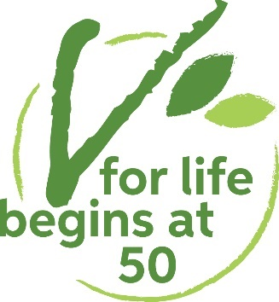

Pen and phone pals scheme

Please fill in the form overleaf if you would like an entry on our vegetarian and vegan pen and phone pals list. We update the scheme seasonally, four times per year. So after returning your form you will next hear from us when we release our next seasonal update.
Please read the notes below first:
- The details you supply will be used for compiling your entry and subscribing you to the pen and phone pal updates mailing list. However, they are not added to any other of our databases/mailing lists.
- This is NOT a dating agency. V for Life reserves the right not to include any inappropriate submissions of this form, including any without an authentic address.
- All accepted submissions will be circulated in the post to all later contacts. It is up to you whether you want to make the first contact or wait for someone to contact you. But if everyone waits not much will happen... try making the first move!
- Older entries are deleted automatically. You can usually expect to be on the list for about a year. Please contact us if you wish to remain listed for longer.
- Respect for other members is our only rule. This means only contact people if you match their search criteria e.g. only contact someone seeking female pen pals if you are female. Never attempt face to face contact without prior arrangement. If someone asks you to stop contacting them, do so immediately. If any of these regulations is overlooked, we will unfortunately have to ban you from the scheme.
- Beyond this… the scheme is for you to use as you feel! We hope you make some fantastic new pen and phone pals.

Disclaimer
V for Life cannot accept any responsibility for anything that happens as a consequence of this service.
We operate this service only as a contact reference point.
We cannot determine if the description of anyone who wants to subscribe to this list is true.

Pen and phone pal scheme application form

Note: All fields must be filled in properly for our confidential records. But those marked with * will not be made public.

First name:....................................................................................................................

Surname*:....................................................................................................................

Gender: Female
Male
Other*
Prefer not to say
*Please let us know if you would like us to add further gender categories.

Age band: 50–60
61–70
71-80
Over 80
Prefer not to say (only permitted for over 50s. We strongly suggest you circle your age group, because it increases your chances of being contacted.)

Are you: Vegetarian
Vegan

In what year did you become vegetarian or vegan?.....................................................

Date of birth*:...............................................................................................................

Address*:.....................................................................................................................

Town/City:.....................................................................................................................

County/State/Region:....................................................................................................

Country:........................................................................................................................

Postcode:......................................................................................................................

Please publish my address in the list: Yes
No

Phone number*:...........................................................................................................

Please publish my phone number in the list: Yes
No

Type of pen pal or phone pal wanted (please circle all that apply):
Pen pal
Phone pal
All genders*
Female
Male

*Please let us know if you would like us to add further gender categories.

Which languages do you want to write/speak in?.........................................................

About you:
In just a few sentences, detail your hobbies, interests, history or whatever you feel like! This will encourage people to contact you.

…..................................................................................................................................

......................................................................................................................................

......................................................................................................................................

......................................................................................................................................

Signed:..........................................................................................................................

Date:.............................................................................................................................

Please return your completed form to:
Vegetarian for Life
83 Ducie Street
Manchester
M1 2JQ
Tel: 0161 257 0887

